**By Student 1**

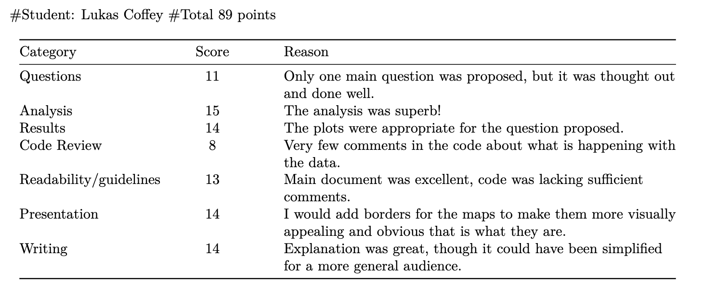

Comments: Adding even a basic border to the US Map, is an option when mapping so I would consider

doing that so it is clear to the reader.

It was slightly confusing when reading through what you were trying to get the clusters to be. If the reader

is not familiar with these concepts, they’d be completely lost. I recommend trying to simplify your verbage

and state in non-statistical speak what you are doing. While it does seem that you know this concept very

well based on your conclusion, being able to simplify complex topics for general consumption a good skill to

Have.

**Total: 89**

**By Student 2**

Questions: 15/15

The question is very new, motivated and insightful.

Analysis : 15/15

The analysis is appropriate and complete. The use of cluster in this problem is very advanced and smart.

Results: 15/15

The result is conpelling and giving out useful suggestion.

Code Review: 15/15

The code is well-commented. The author named variable very well make it easy to read.

Readability and Guidelines: 15/15

I think there is still room for improvement for analysis aspect. For example, the shape of scatters in plot 1-4

can be in different shape to improve the readiness.

Presentation: 15/15

Very nice presentation. The presentation are appealing. Something he can improve is to add stuff like

“figure1.xxx” in the bottom of a plot.

Writing:15/15

Author did a great job in writing. He bolded everything that is important.

**Overall: 105/105**

**By TA/Instructor:**

The average score from your two peer reviews is a 97. Their comments were thoughtful, and we have nothing further to add. We feel like a 97 is appropriate, so that’s what we’ll assign you.

**Overall grade: (89 + 105)/2 = 97**